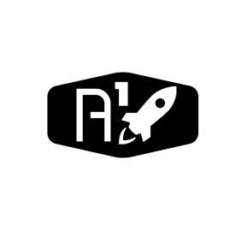

DESIGN DOCUMENT

Area : Converse Engine

Category: Feed (Purge)

TEAM: Propulsion

Nyameaama Gambrah

Engine Purge System

LOX Line

Fuel Line

LOX Purge Pipe Vent

Fuel Purge Pipe Vent

C-Chamber

Electrical

Pressure loss

Valve

Pipe 2-Way

Nitrogen Gas